CR TITLE | VENDOR STATUS TO BE CHANGED AUTOMATICALLY TO ¨LOCKED¨ ONCE THE ¨ONE-TIME VALIDITY EXPIRATION DATE¨ IS REACHED IN SAM
Submitted on : | 12/01/2023

All sections are mandatory. When not applicable, please mention ‘N/A’.
Red sections must be filled by CR Requestor, Green sections by the Change Advisory Board,
Blue sections by ITICS Finance & Procurement.

REQUESTOR INFORMATION
(To be provided by CR Requestor)
First Name & Last Name | Agnieszka Przeorska
Region | EUROPE
E-Mail Address | agnieszka.przeorska@capgemini.com

CHANGE REQUEST MAIN INFORMATION
(To be provided by CR Requestor)
TITLE | Vendor status to be changed automatically to ¨Locked¨ once the ¨One-time validity expiration date¨ is reached in SAM
Priority | 2 - Medium
Priority Justification | Solution suggested by the OBO Manager
ITICS Finance & Procurement Applications | SAM
Legal Requirement | No
Legal Requirement Description | N/A
Legal Requirement Deadline | N/A
Requested Implementation Date | N/A
Purpose of the CR | Modification
Component Number & Name | N/A
Module(s) Names (if applicable) | N/A
EARS Ticket (if applicable) | N/A

CHANGE REQUEST DETAILED DESCRIPTION
(To be provided by the Change Request Requestor)
A relevant information is needed on the vendor level: The vendor status should be changed to ¨Locked¨ whenever the One-Time date has expired.
- Vendor status should be automatically changed to ¨Locked¨ every time the ¨One-time validity expiration date¨ is reached in SAM;
- A vendor status shouldn´t longer be ¨Active Supplier¨ when the ¨One-time validity expiration date¨ is reached in SAM.

Attachments

Required view:
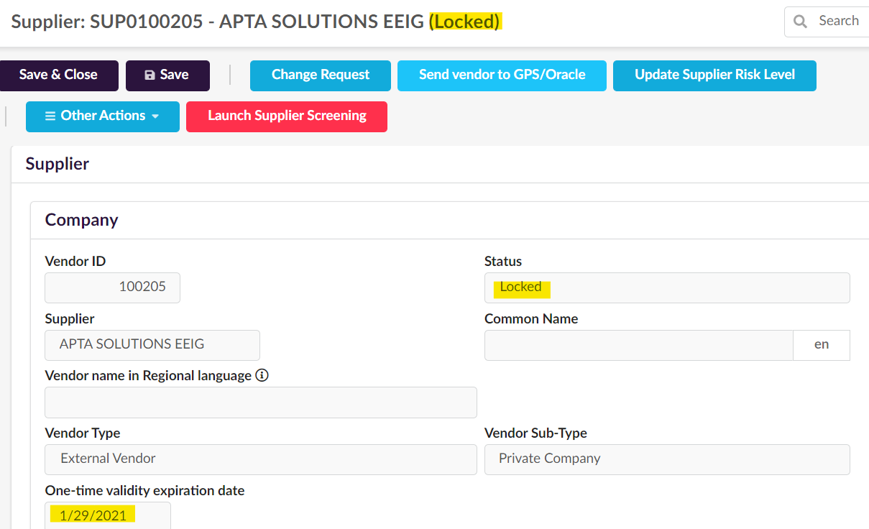

Current view:
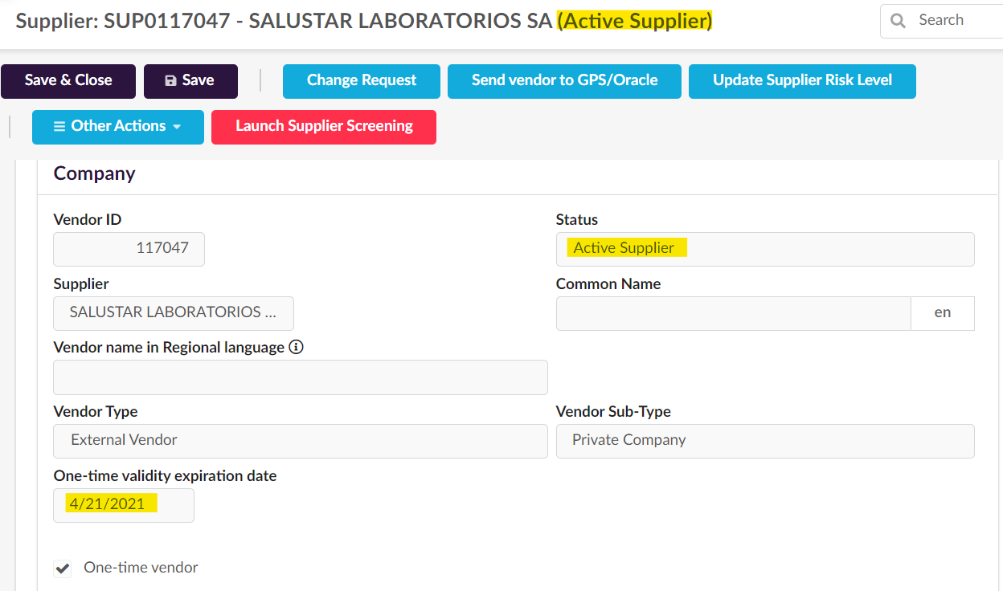

Test Cases & Expected Results
A relevant information is showed in SAM for all vendors with a ¨One-Time¨ date determined, and it informes upfront if the vendor is locked or active.

Volume / Frequency
To be updated automatically for all vendors with ¨One-Time¨ date, every time a ¨One-Time¨ date expires in SAM.
Reason for the change request (Benefits, What if the CR is not implemented)
A more useful view in SAM is required, as the current setup shows false information about the vendor status.
Currently, when the ¨One-Time¨ date is expired, the status remains ¨Active supplier¨, when, in fact, the supplier is locked for PO creation/payments, and its status should also be automatically set up us ¨Locked¨.
If thr CR is not implemented, thousands of vendors will show incorrect information that is not corresponding to their real status.

To register the CR, please send the document to following ITICS Finance & Procurement Distribution List :

Incomplete CR will be returned to the CR Requestor.

CHANGE ADVISORY BOARD EVALUATION
(To be provided by the Business Solution Lead)
Business Solution Lead / CR Reviewer | Name of the Business Solution Lead / CR Reviewer
CR Business Validation Date | DD/MM/YYYY
CR Acceptance Status | Please select a value
CR Rejection Reasons | If CR is rejected by the Business Change Board, please provide the reasons.
Submitted to other regions agreement | Mandatory for CR impacting more than one region.  Please select a value
Business Board Change comments | Please provide detailed business review comments that will help to prioritize this CR and plan the Release date.  If known/applicable, please provide :  - Earliest release date (in case other applications are impacted and all releases needs to be coordinated).  - Release date at the latest (in case of a Legal Requirement/planned Go Live).

IMPACTS ASSESSMENT
(To be provided by the Business Solution Lead)
Impacts to other Regions | Please list the other regions impacted by this CR.  Example : CR India Working Hours changes impacts all GFS regions.
Impacts on Local Applications | Please specify if Local applications will be impacted by this CR.  If yes, list the regions & name/use of the systems impacted.  Ex : France - WTR (Timecard system).
Impacts on Group Applications | Please specify if Group applications will be impacted by this CR.

To register the CR, please send the document to following ITICS Finance & Procurement Distribution List :
DL IN NOP SUPPORT

Please ensure to update the CR document with the CAB Evaluation section and upload the new version in the ITICS Finance and Procurement Troom

CR EVALUATION

(To be provided by ITICS F&P CR Analyst)
Category | Please select a value
Business Process impacted | Please select a value
ITICS F&P Application impacted | Please select a value
ITICS F&P Applications for which a child CR must be created | Please specify for which other impacted ITICS Finance Applications a child CR must be created.
Comp. #, Setup, Sched | Please specify component number(s) that will be impacted, or if CR will be implemented through Setup, Scheduling, Patch and/or other.
Component Name | Name of the component, report or feature
Core Component | Please select a value
CR associated to Customization Component artifact | Please select a value
Requestor Region
Other Regions Impacted
Legal Requirement | Please select a value
Priority | Please select a Priority
Known constraints for Release Date (Legal deadline, Go Live, etc)
Other applications impacted
Impacts on Performance | If applicable, please provide any comments related to Performance
Initial Analysis comments | Please describe functional/technical impacts due to this CR implementation.  Please provide any other comments that will help determining CR acceptance or rejection.
Complexity | Please select a value

ITICS FINANCE & PROCUREMENT VALIDATION
(by ITICS Finance & Procurement CR Review Committee)
ITICS F&P CR Analyst | Name of the CR Analyst
CR ITICS F&P Validation date | DD/MM/YYYY
CR Acceptance Status | Please select a value
Rejection reasons | If CR is rejected, please provide the reasons
Comments for Release Plan | Target Release month for CR with strong constraints for implementation date due to Legal deadline or planned Go Live.

Please ensure to update the CR document with the ITICS Finance & Procurement Evaluation section and upload the new version in the ITICS Finance and Procurement Troom

